POLICE SCOTLAND / INDUSTRY

ANNUAL WEAPONS/SECURITY AUDIT SUBMISSION

January 2020

Purpose:

This document is intended to assist the off-shore industry submit annual evidence of continued off-shore installation security, in respect of licenced weapons and ammunition held for gas flare ignition operational requirements.

At an operational level, the aim is also to provide a single company firearms reference document that will inform and assist Police Firearms Licensing Officers assess of the suitability of applicants who intend to utilise company licenced flare ignition assets/equipment.

Company Profile

XXXXXXXXXX is a major oil and gas exploration and production company with a significant stake in the North Sea Region. These operations are controlled from the company’s Aberdeen HQ premises for which the full contact details are as follows:

XXXXXXXXXXX UK Ltd
XXXXXXXXXXX
XXXXXXXXXXX
XXXXXXXXXXX
Aberdeen
ABXX XXX

Company E-Mail Address
Company Tel No.

XXXXXXXXXXXX operates at total of (insert number) North Sea Region Installations / FPSOs and one land-based site at which firearms and ammunition are deployed. These are:

- Blue Platform
- Black Platform
- Green Platform
- Yellow FPSO
- White FPSO
- Headland Gas Terminal

Company Master Certificate Holder(s)

The company has * one / two / three Master Certificates holders who are based at the company’s Aberdeen HQ. Details of these persons are as follows:

Name | Role | Tel No. | FAC No. | SGC No.
 | Security Manager | XXXXXXXXXX | XXXXXXX | XXXXXXX
E-Mail Address |  | XXXXXXXXXXXXXXXXXX

Name | Role | Tel No. | FAC No. | SGC No.
 | HSE Manager | XXXXXXXXXX | XXXXXXX | XXXXXXX
E-Mail Address |  | XXXXXXXXXXXXXXXXXX

Name | Role | Tel No. | FAC No. | SGC No.
 |  | XXXXXXXXXX | XXXXXXX | XXXXXXX
E-Mail Address |  | XXXXXXXXXXXXXXXXXX

Company Certificate Holder(s)

Name | Role | FAC No. | SGC No.
Example - John Smith | Security Manager | XXXXXXX | XXXXXXX

Company Firearms

The company owns a number of *Section 1 only / *Section 2 only / *Section 1 and 2 firearms (delete as appropriate). The current stock of guns is listed below and also on the Company Master Certificate Holder’s FAC and / or SGC.

The installation / site security arrangements involve the storage of firearms and ammunition that conform to police firearms licensing requirements.

The company’s current stock of firearms is as follows:

No. | Make | Gauge | Type | Serial No. | Barrel Length | Asset
1. | Greener | 12G | Shotgun-Flare Ignition | XXXXXXX | 23” (Section 1) | Blue Platform
2. | Baikal | 12G | Shotgun-Flare Ignition | XXXXXXX | 23” (Section 1) | Black Platform
3. | Browning | 12G | Shotgun-Flare Ignition | XXXXXXX | 28” (Section 2) | Green Platform
4. | Browning | 12G | Shotgun-Flare Ignition | XXXXXXX | 28” (Section 2) | Yellow Platform
5. | Browning | 12G | Shotgun-Flare Ignition | XXXXXXX | 28” (Section 2) | White Platform
6. | Browning | 12G | Shotgun-Flare Ignition | XXXXXXX | 28” (Section 2) | Headland Terminal

Firearms and Ammunition Security - General

Gun and ammunition cabinets that conform to BS 7558 are fitted at all sites where flare ignition equipment and materials are held. These cabinets are all suitably located to ensure good levels of supervision and are fastened to the fabric of the structure or building with bolts sufficiently robust as to prevent unauthorised removal - as per the standards set out in the Home Office Firearms Security Handbook 2019.

The keys for these cabinets are kept secure at all times within a separate combination key safe and access to these keys is very strictly restricted to authorised and certified firearms users only.

Site specific security information is described for each installation / site below.

Storage onshore

The company *does / does not (*delete/amend as appropriate) have any onshore gun or ammunition storage facilities.

*All company firearms and ammunition which are held onshore are securely stored by company approved Registered Firearms Dealers (RFD) or with a person who is acting on behalf of the company and in possession of the appropriate authority to possess.

The company’s current approved RFD is:

RFD Name | Tel No. | RFD No.
 | XXXXXXXXXX | XXXXXXX
E-Mail Address | XXXXXXXXXXXXXXXXXX

The company’s approved authority to possess is:

Name | Tel No. | Cert No.
 | XXXXXXXXXX | XXXXXXX
E-Mail Address | XXXXXXXXXXXXXXXXXX

Installation / FPSO / Site Security Arrangements (Separate Forms required for each asset)

- Name - Green Platform

- Field – Forties

- Installation Firearm

Make | Gauge | Type | Serial No. | Barrel Length
Browning | 12G | Shotgun-Flare Ignition | 54536ZT | 28”
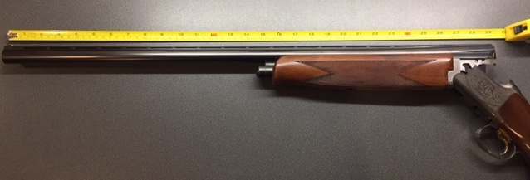
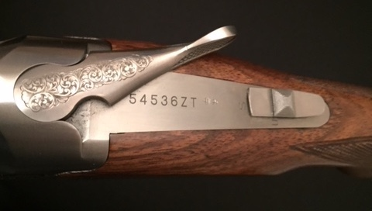
Time, Date of Photographs taken and Location:

……………………………….

Gun Security

A BS 7558 3-gun cabinet is installed within the OIMs office and is secured to the wall and floor with bolts sufficiently robust as to prevent unauthorised removal. This location affords good levels of general supervision as this office is adjacent to the Control Room which is manned on a 24 / 7 basis.

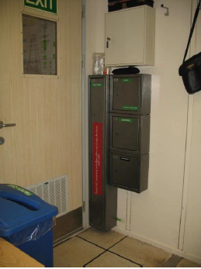

Time, Date of Photograph taken and Location:

……………………………….

Flare Ignition Ammunition / Security

As the company exclusively uses 12G firearms for flare ignition operations, the flare cartridges used are Primetake PT1003 Gas Flare Ignition cartridges which are classed as Section 1 ammunition and have a shelf life of 5 years.

There is an upper stock limit of (insert amount) flare cartridges for asset (insert name)

A BS 7558 ammunition cabinet with a capacity to hold (insert number – 300?) x 12G cartridges is installed within the OTLs office and is secured to the wall with 10mm bolts.

This location affords good levels of general supervision as it is located on the same corridor as the Control Room which is manned on a 24 / 7 basis.

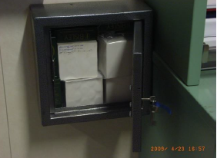

Time, Date of Photograph taken and Location:

……………………………….

Key / Access Control Arrangements

Access to the above gun and ammunition cabinets is very strictly controlled and restricted to staff members with the appropriate FAC and / or SGC authorities. Additionally, before the installation / site firearms and ammunition are deployed, the express authority of the *OIM / Area Authority is required and a *Work Control Certificate / Permit to Work with clearly defined instructions governing their use, must be issued.

On the Green Platform, the method of physically securing the gun and ammunition keys is through the use of an approved key safe, as shown below, which is *bolted to the wall in the Control Room / held within the OIM’s safe. As stated above, the combination for this key safe is strictly confined to authorised firearms users and this code is reset on a quarterly basis.

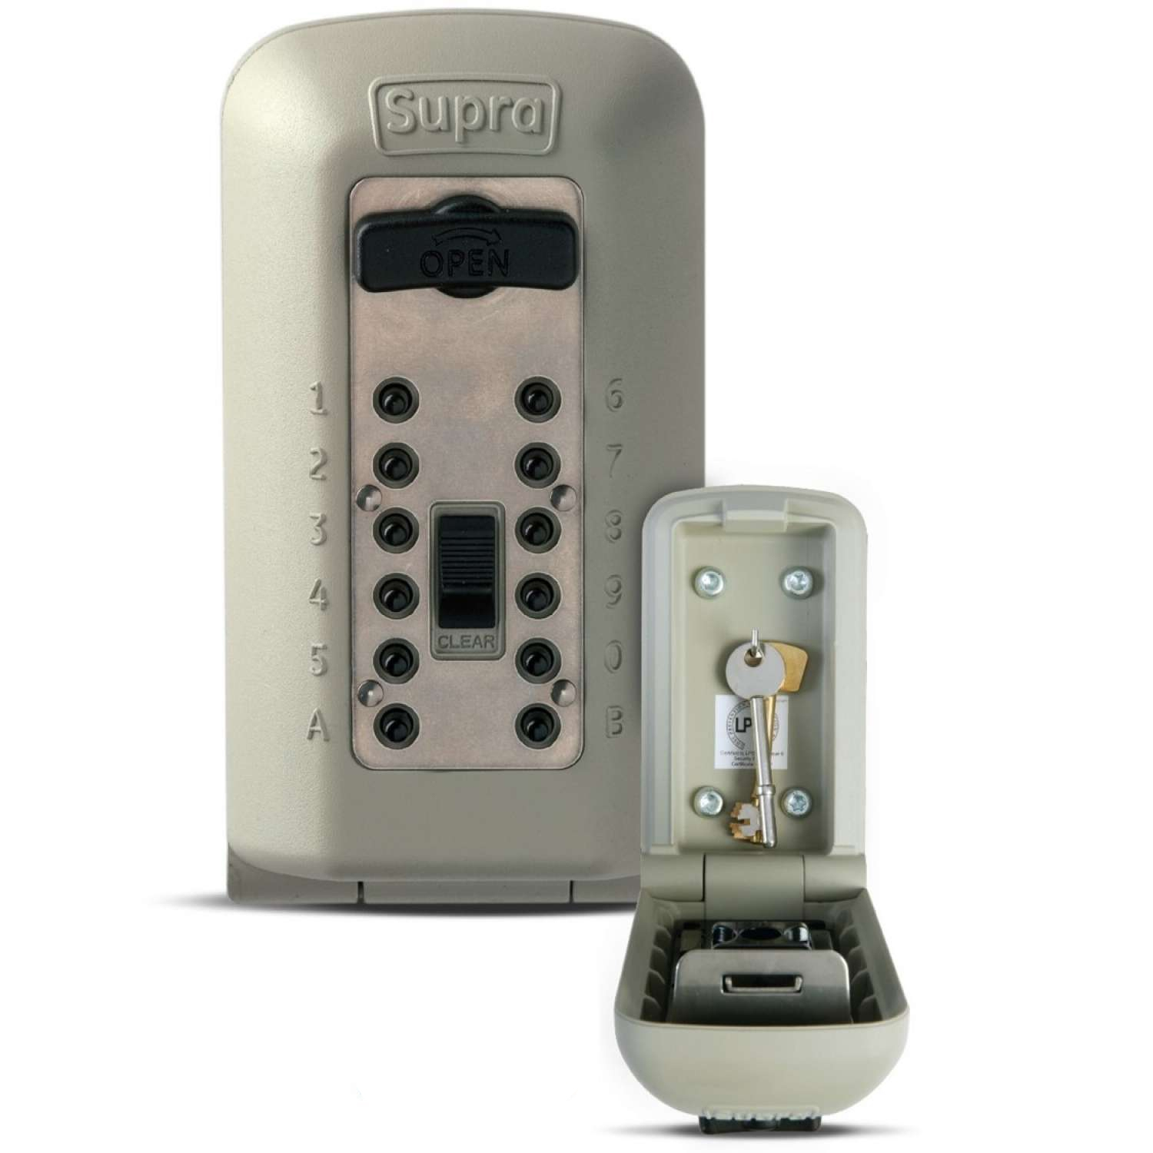

Time, Date of Photograph taken and Location:

……………………………….

Signature of person submitting: ……………………………………..

Designation: ……………………………….

Date Submitted: …………………………..

